ABBREVIATED GREEN SPRING COMMISSIONERS MEETING MINUTES, MAY 20, 2021
The meeting was called to order at 7:04 via Zoom by Mayor Trevor Cravens. Present were Commissioners Josh Combs, Scott Radeker, Stuart Ries, Chris von Allmen, and City Attorney Chip Hayward. Several Green Spring residents were also in attendance..
Minutes from the April 2021 Commissioner’s meeting were approved unanimously.
The monthly Security Report was emailed to commissioners prior to the meeting and included nothing of significance.
Beautification, Commissioner Chris von Allmen
Pro – Turf finalized spring plantings and mulching. 3-4 pieces of landscape will be replaced or removed. Commissioner von Allmen spoke to them about doing a better job of mowing NE corner of Wolf Pen, to also clear out underbrush of trees so it looks better kept. Greenway has started mowing Springdale Corridor. Contacted painter for Wolf Creek Sign to get a quote. Waiting on formal quote to proceed with coat of electrostatic paint. Dan the handyman put a couple coats of sealant on the median at neighborhood entrance.
City Services, Commissioner Josh Combs
Run off Drainage Pipe: Resident had an issue with a clogged concrete drainage culvert. I contacted MSD. Issue will be addressed within 30-45 days. Rumpke: Continue to have several complaints with the current waste pick-up. I’ve been in frequent contact with Christopher Pierce (our Municipal Sales Rep). The last communication was that he would have a supervisor run through our city after pick-up and make sure everything looked good. That was on 5/7. No complaints since. There has been a bit of employee turnover at Rumpke, which may explain some inconsistencies.
Finance, Commissioner Stuart Ries
Income from all sources for April 2021 was $3,507.40. April expenses were $211,832.53.
Major April Expenses:
Trash Collection $6651.60
Electricity $1303.00
Security $1750.00
Lawn Care $1205.00
Water $420.48
New Business: We will have the first reading of the 2021-2022 tax ordinance. The proposed tax rate is $0.1700 per $100 of assessed value.
We will have the first reading of a municipal ordinance to increase the 2020-2021 budget by $215,000 for the purpose of road maintenance.
We will have a resolution to increase the service rate of the non-contiguous sections of Green Spring from a 0.3 multiplier to a 0.5 multiplier. This is anticipated to generate an additional $800 per year of tax revenue.
Old Business 2021-2022 Budget: We will have the second reading of the FY 2021-2022 budget.
The budget is based on a proposed real and personal property tax rate of $170/$100 of assessed value.
Transportation, Commissioner Scott Radeker
Paving Project: On Monday, June 21st Commonwealth Paving will begin installing liquid road to our city streets. The city will be split into (4) sections with each section taking (2) days each. On the days each area is being done all cars will need to be out of the driveway from 7:30 am to 6:00pm both days. At 6:00pm each day the barricades will be removed by Commonwealth Paving and residents will be allowed to park at their homes.
Please see the color coordinated map for the days each area will be affected. Red section, Monday 6/21 and Tuesday 6/22. Purple Section, Wednesday 6/23 and Thursday 6/24. Green section, Monday 6/28 and Tuesday 6/29. Brown Section, Wednesday 6/30 and Thursday 7/1. Should rain cancel any day, residents will be notified of the make-up date after all other scheduled work is completed.
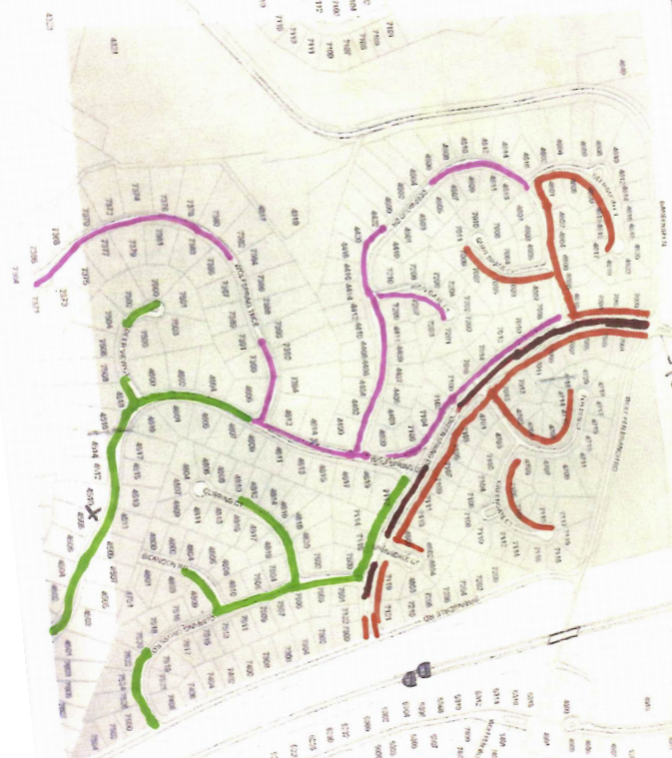

OLD BUSINESS
- Second reading of the 2021-22 Budget Ordinance. Passed unanimously.
NEW BUSINESS
- Ordinance to revise the 2020-2021 budget to include $215,000 from savings for municipal road improvements. First reading.
- Ordinance to establish the ad valorem tax rate at $0.170 per $100 of assessed value for the 2021-2022 tax year. First reading.
- Municipal Resolution to establish the city service rate for the parcels in The Overlook subdivision at 50% beginning with the 2021-2022 tax year. In favor: Commissioners Radeker, Combs, Ries. Opposed: Commissioner von Allmen. Resolution passed.
The next meeting will be held on June 17, 2021, 7 pm, at a location TBD. The meeting was adjourned at 8 pm.

